24 Port 1U Rackmount CAT5E UTP Modular Patch Panel (PPAN-24-THRU)
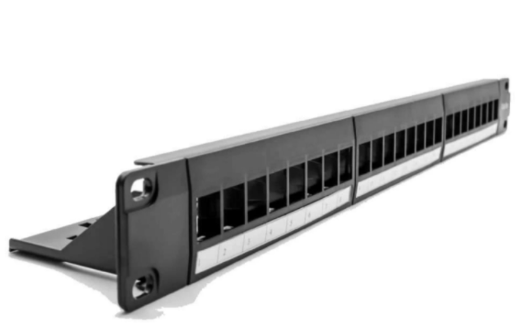

Description:
The LMS Data PPAN-24-THRU is 24 Port certified CAT5e UTP Patch Panel which is unique in that it has fully modular and replaceable CAT5eUTP ports. Simply snap in or snap out and mix and match with other accessories or when a port is damaged.

Fully Gigabit Ethernet certified means its ideal for running legacy and advanced networking protocols to Gigabit Switches up up to 1000Mbps. Also ideal for telecom, VoIP, CCTV-IP and other Ethernet based standards.

Long-life, nickel plated female RJ45s, the port modules use a through-coupler system so simply connect a RJ45 terminated cable to the rear of the panel.

Built-in ease of maintenance. Offering ease of maintenance and instant connectivity for both End Users and installers alike, the new LMS Data PPAN-24-THRU is your ideal solution for running the latest Networking, Voice and Telco applications. Fully modular in design, the Patch Panel allows each RJ45 module to be replaced if necessary, say for example, running mixed media of both UTP and STP modules within the same 19” Patch Panel. Ideal for Fast Ethernet and Gigabit (1000BaseT) applications, the PPAN-24-THRU allows instant connectivity to any size of Network. Using quality components throughout, the modules are made of ABS Plastic and feature gold conductors for low impedance levels, all secured within a metal framed enclosure. Full port ID comes as standard together with the option of modifying the port ID sequence.

Key Features:
- 24-Way UTP through coupler Patch Panel
- Class-leading CAT5e/ISO-11801 compliant
- Gold Plated, high conductive connectors
- Supports Gigabit (1000BaseT) Ethernet, Telco
- Modular, field replaceable outlets, clip & fit
- Front numbered, 1U high, 19” design
- Ideal for fast fit Structured Cabling installations

Specifications
- 48-Port, High-Density 2-U Through Coupler Patch Panel
- Performance Cat5e UTP certified - Gigabit Compliance
- Easy-Clip, modular through coupler design*
- Meets or Exceeds current Category 5e performance
- Built-in LAN port redundancy - Easy to swap out
- High conductive, gold-plated RJ45 connections
- Individual port numbering (1-48)
- Supplied with x2 clip-on alloy rear cable management bars
- Supplied with standard M6 cage nuts, bolts and washers

Applications:
- Office, Education and Home Structured Cabling Installs
- Ideal for Gigabit Ethernet (1000Mbps) Data Networks
- Create fault tolerant LANs by simply patching ports

Product Code:
- Part Number: PPAN-24-THRU
- EAN: 8400800032188
- Weight: 0.5Kg approx.

Technical Specifications:
- Port Count： 24 Ports UTP
- Dimensions：1U 19-Inch Design Format
- Design：Through Coupler System
- Performance ：10/100/1000Mbps Gigabit Compliance
- RJ45/IDC Connects：Nickel and Phosphor Bronze
- Port Identification： Numbered
- Fixings：Supplied M6 Nuts and Bolts
* Specifications and product design are subject to change. E&OE.

